Dear Stakeholder / Resident,

**Cathedral Business Park – Seaward (Bognor Road ) Ltd**

I am writing to introduce Mildren Construction, the Principal Contractor appointed by the Developer to complete the first phase construction of Cathedral Business Park on the former Fuel storage facility on the A259, Bognor Road, Chichester.

The project involves the construction of a new builders’ merchants, on-site infrastructure works including an access road, drainage and associated external works. Full details of the proposed development are available to view via Chichester District Council’s public access planning register under planning reference no. 21/03064/FUL.

Also involved as part of the project are the Section 278 highway works along the existing A259 Bognor Road (Dual Carriageway), these include a new permanent signalised entrance into the Business Park, including the formation of site entrance road, filter lane on the A259 and a signalised pedestrian crossing. To accommodate these highway works off-peak day-time lane closures (westbound) and night-time closures will be enforced to ensure safety of our workforce.

The first full road closure (Westbound) is due 22nd September 2022, to allow the installation of safety zones and narrow lanes.

Details of this road closures and future traffic management phasing can be found on our community web-site [www.BognorRoad.com](http://www.BognorRoad.com)

The project is due to commence on 12th September 2022 and is programmed to be completed early summer 2023.

Founded over 34 years ago, Mildren Construction is a regional contractor based in Christchurch, Dorset which operates throughout the south of England. Our Chairman and principal shareholder Chris Wingham, together with his team of five directors, participate in the day to day management of the company, and are working closely with our client on detailed forward planning to minimise the impact of our works on the local community.

Our Site Manager Mark Hill will be based on site during the construction period. He can also be contacted on 07460 266 686.

We thank you for your co-operation and patience during this time and want to reassure you that we will do all we can to minimise disruption. If you have any questions or comments, then please do not hesitate to contact Mark on the number above or myself.

Yours faithfully,



Nicki Main

Mildren Construction Communication Officer

01202 487 480

**Planned Road Closure – Night Thursday 22.09.2022**

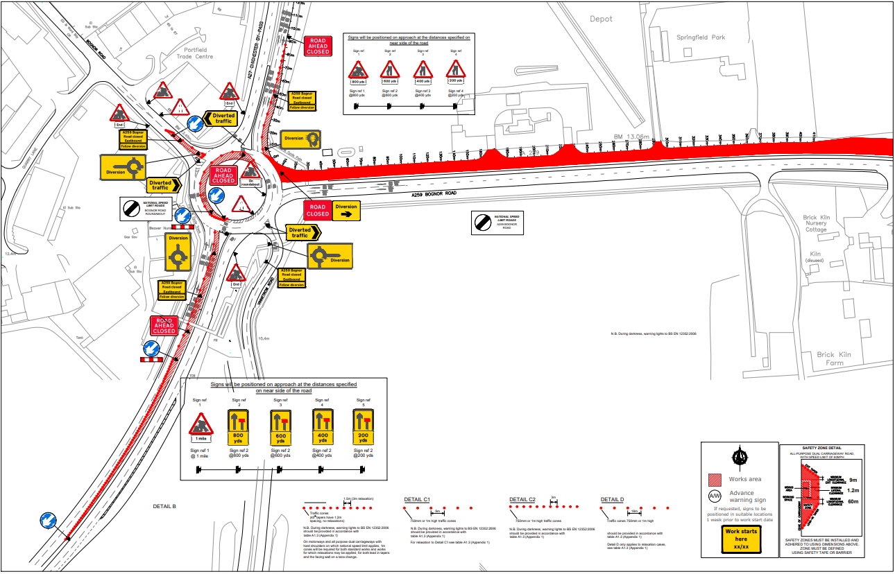

**Eastbound Traffic (Narrow Lanes) from 23.09.2022**

